Data Analytics Project
(HR Analysis)
Testing Power Bi Report in SQL
Create Table
create table hrdata
(
emp_no int8 PRIMARY KEY,
gender varchar(50) NOT NULL,
marital_status varchar(50),
age_band varchar(50),
age int8,
department varchar(50),
education varchar(50),
education_field varchar(50),
job_role varchar(50),
business_travel varchar(50),
employee_count int8,
attrition varchar(50),
attrition_label varchar(50),
job_satisfaction int8,
active_employee int8
)

Import Data in Table Using Query
COPY hrdata FROM 'D:\hrdata.csv' DELIMITER ',' CSV HEADER;

1.Employee Count
select sum(employee_count) as Employee_Count from hrdata;
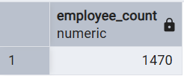
Test on:
i).select sum(employee_count) as Employee_count from hrdata
where education='Associates Degree'
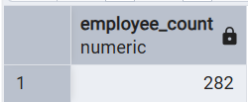
ii).select sum(employee_count) as Employee_count from hrdata
where age_band='Under 25' and gender='Male'
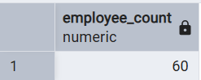
iii). select sum(employee_count) as Employee_count from hrdata
where job_role='Healthcare Representative'
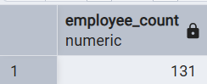
iv) select sum(employee_count) as Employee_count from hrdata
where education_field='Human Resources'
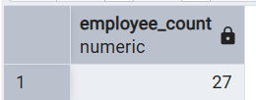

2.Attrition Count
select count(attrition) as Attrition_Count from hrdata where attrition='Yes'
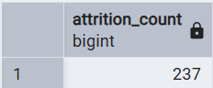
3.Attrition Rate
select round(((select count(attrition) from hrdata where attrition='Yes')/sum(employee_count))*100,2) from hrdata
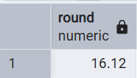
4.Active Employee
select sum(employee_count)-(select count(attrition) from hrdata where attrition='Yes') as Active_Employee from hrdata
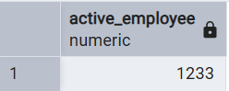
5. Average Age
select round(avg(age),0) as Avg_Age from hrdata
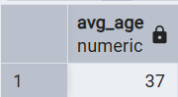
6.Department wise attrition
select department,count(attrition),
round((cast(count(attrition) as numeric)/(select count(attrition)
from hrdata where attrition='Yes')) *100,2) as pct
from hrdata where attrition='Yes' group by department
order by count(attrition) desc;
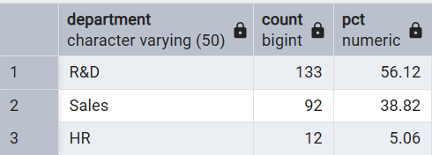

7.No. of Employee by age group
select gender,age_band,sum(employee_count) as Employee_Count from hrdata
group by gender,age_band
order by age_band;
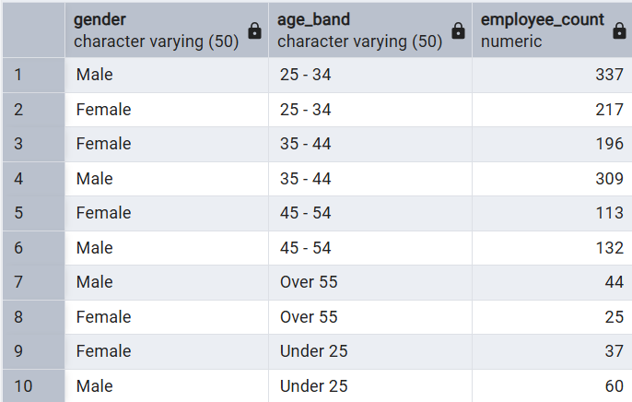
8.Job Satisfaction Rating
CREATE EXTENSION IF NOT EXISTS tablefunc;
select * from crosstab(
'select job_role,job_satisfaction,
sum(employee_count) from hrdata
group by job_role,job_satisfaction
order by job_role') as ct(job_role varchar(50),
one numeric, two numeric, three numeric,four numeric)
order by job_role ;
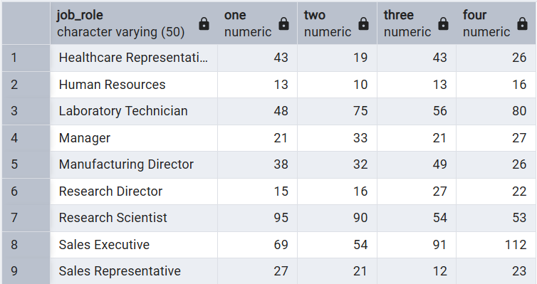
9.Education field wise Attrition
select education_field,round(count(*) filter
(where attrition='Yes')*100/sum(employee_count),2) as attrition_rate
from hrdata
group by education_field
order by attrition_rate desc;
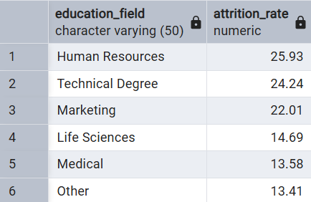
10.Attrition rate by gender for different Age group
select age_band,gender,count(attrition),round((cast(count(attrition) as numeric)/
(select count(attrition) from hrdata where attrition='Yes'))*100,2) from hrdata
where attrition='Yes'
group by age_band,gender
order by age_band,gender;
